More Three-Body Systems

- Three masses are connected by light, inextensible ropes and two frictionless pulleys, as shown. A 2 kg mass hangs on the left, connected by a rope over a pulley to an 8 kg block that rests on a frictionless horizontal surface. The 8 kg block is connected by a second rope over another pulley to a 5 kg mass hanging on the right. Because the ropes are independent, the tensions in each rope are not necessarily equal.

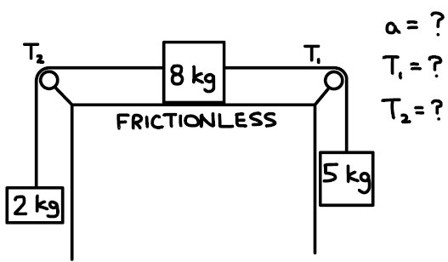
  - Determine the acceleration of the system.
  - Determine the tension $T_{1}$in the rope connecting the 8 kg and 5 kg masses.
  - Determine the tension $T_{2}$in the rope connecting the 8 kg and 2 kg masses.

- Three masses are connected by light, inextensible ropes and two frictionless pulleys, as shown. An 8.0 kg block rests on a horizontal surface where the coefficient of kinetic friction is $μ=0.60$. A rope on the right connects the 8.0 kg block to a 10.0 kg hanging mass; the tension in this rope is labeled $T_{1}$. A second rope on the left connects the 8.0 kg block to an unknown hanging mass $m_{3}$; the tension in this rope is labeled $T_{2}$. It is known that the tension in the right rope is $T_{1}=92\text{ N}$.

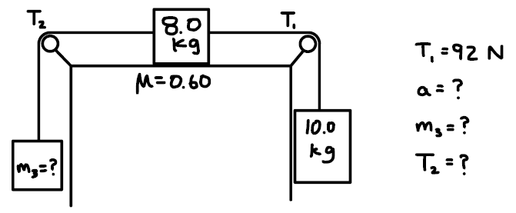
  - Determine the acceleration of the system.
  - Determine the value of the unknown mass $m_{3}$.
  - Determine the tension $T_{2}$in the left rope.

- Three blocks are connected by light, inextensible ropes and two frictionless pulleys, as shown. A 10 kg block rests on a 45° incline and is connected by a rope over a pulley to a 20 kg block on a horizontal surface with coefficient of kinetic friction $μ=0.20$. The 20 kg block is connected by a second rope over another pulley to a 30 kg hanging block. The system is released from rest.
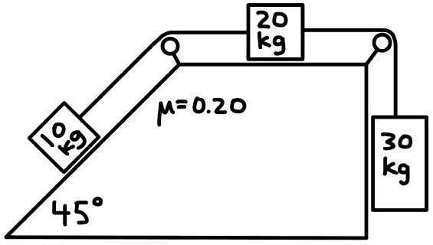
  - Determine the acceleration of the system.
  - Determine the tension in the rope connecting the 10 kg and 20 kg blocks.
  - Determine the tension in the rope connecting the 20 kg and 30 kg blocks.

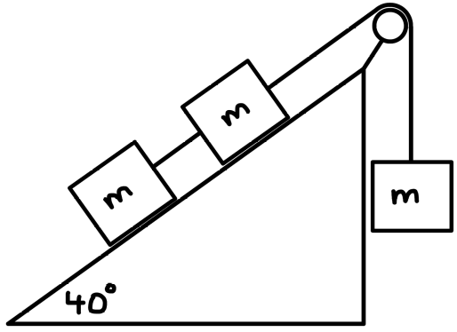
- Three identical blocks, each of mass $m$, are connected by light, inextensible cords over a frictionless pulley, as shown. Two of the blocks lie on a 40° incline, and the fourth block hangs vertically on the other side of the pulley. The system is released from rest. For each case below, determine the acceleration of the system (magnitude and the direction of motion of each block):

  - The incline is frictionless.
  - The incline has a coefficient of kinetic friction $μ=0.10$.
  - The incline has a coefficient of kinetic friction $μ=0.30$.

- Three identical blocks, each of mass $m$, are connected by light, inextensible cords and are arranged as shown. One block rests on a 30° incline with a coefficient of kinetic friction $μ=0.45$. The rope passes over two frictionless pulleys, connecting the block on the incline to a hanging block on the left and another hanging block on the right. The system is released from rest.
  - Determine the acceleration of the system (magnitude and the direction of motion of each block).
- Determine the tension in each cord. (There are two cords and therefore two different tensions.)
