More Two-Body Systems

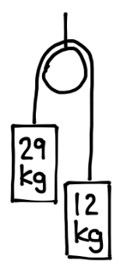
- Two masses are connected by a light, inextensible cord that passes over a frictionless pulley. One mass is 29 kg and the other is 12 kg, as shown. Assume the system is released from rest.
- Determine the acceleration of the system. (State which mass moves upward and which moves downward.)
- Determine the tension in the cord.

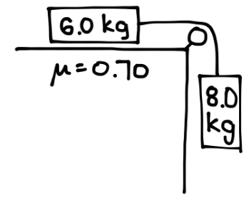
- A 6.0 kg block rests on a horizontal surface where the coefficient of kinetic friction is $μ=0.70$. The block is connected by a light, inextensible rope that passes over a frictionless pulley to a hanging 8.0 kg mass, as shown. The system is released from rest.
  - Determine the acceleration of the system. (State the direction of motion of each mass.)
  - Determine the tension in the rope.

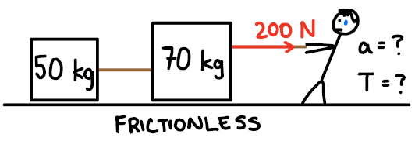
- Two blocks of mass 50 kg and 70 kg sit on a frictionless horizontal surface and are connected by a light rope. A person pulls horizontally on the 70 kg block with a 200 N force, as shown. Assume the rope is massless and the surface is frictionless.
  - Determine the acceleration of the system.
  - Determine the tension in the rope between the two blocks.

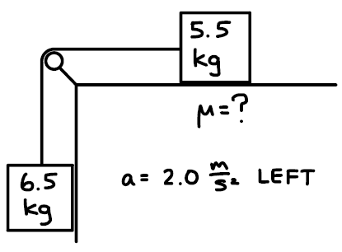
- A 5.5 kg block rests on a horizontal surface and is connected by a light rope over a frictionless pulley to a 6.5 kg hanging mass, as shown. When released, the system accelerates at $2.0 {\text{m/s}}^{2}$to the left for the block on the table.
  - Determine the coefficient of kinetic friction between the 5.5 kg block and the surface.
  - Determine the tension in the rope.

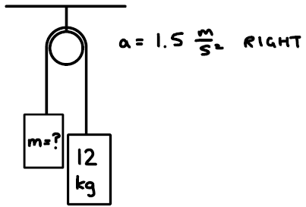
- Two masses are connected by a light, inextensible rope that passes over a frictionless pulley, as shown. One mass is 12 kg, and the other has unknown mass $m$. When released, the system accelerates at $1.5 {\text{m/s}}^{2}$to the right (meaning the 12 kg mass moves downward and the unknown mass moves upward).
  - Determine the value of the unknown mass $m$.
  - Determine the tension in the rope.

- A 10 kg block rests on a horizontal surface where the coefficient of kinetic friction is $μ=0.50$. The block is connected by a light rope over a frictionless pulley to a hanging 8 kg mass, as shown. When released, the 8 kg mass would normally pull the 10 kg block toward the pulley, but a person pulls horizontally on the 10 kg block with a force of $180\text{ N}$in the direction opposite the motion. As a result of the person’s pull, the system accelerates to the right for the 10 kg block and upward for the 8 kg mass.
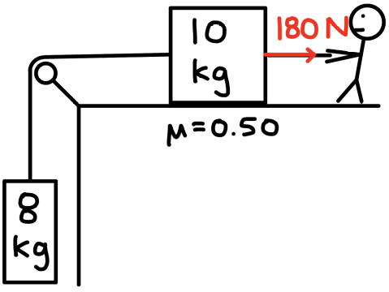
    - Determine the acceleration of the system.
    - Determine the tension in the rope.

