Series Circuits

For each resistor, determine:
the current through the resistor
the voltage drop across the resistor
the resistance of each resistor

For the entire circuit, determine:
the total resistance
the total voltage of the circuit
the total current supplied by the battery

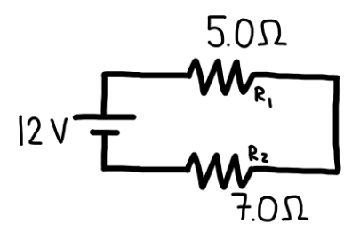
- A 12.0 V DC battery is connected in series with two resistors, as shown in the diagram:
- Resistor $R_{1}=5.0 Ω$
- Resistor $R_{2}=7.0 Ω$
Assume all components are ideal and connecting wires have negligible resistance.

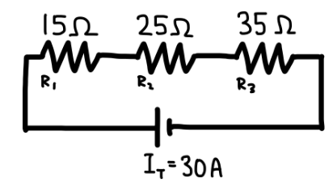
- A series circuit consists of three resistors connected to a DC power source, as shown in the diagram:
- $R_{1}=15 Ω$
- $R_{2}=25 Ω$
- $R_{3}=35 Ω$
The total current supplied by the source is $I_{\text{total}}=30\text{ A}$ Assume all components are ideal and connecting wires have negligible resistance.

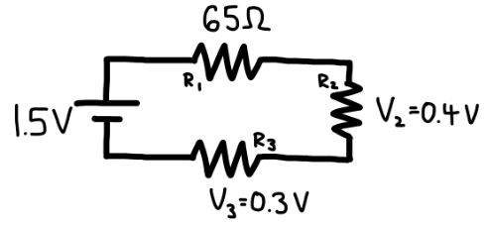
- A 1.5 V DC battery is connected in series with three resistors, as shown in the circuit diagram. The following information is known:
- $R_{1}=65 Ω$
- The voltage drop across $R_{2}$is $V_{2}=0.40\text{ V}$
- The voltage drop across $R_{3}$is $V_{3}=0.30\text{ V}$
Assume all components are ideal and the resistance of connecting wires is negligible.

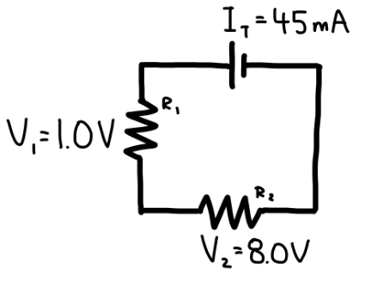
- A series circuit consists of two resistors, $R_{1}$and $R_{2}$, connected to a DC power source, as shown in the diagram. The following information is known:
- The total current in the circuit is $I_{\text{total}}=45\text{ mA}$
- The voltage drop across $R_{1}$is $V_{1}=1.0\text{ V}$
- The voltage drop across $R_{2}$is $V_{2}=8.0\text{ V}$
Assume all components are ideal and the resistance of the connecting wires is negligible.
Parallel Circuits

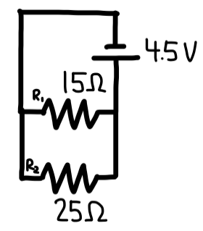
- A 4.5 V DC battery is connected to two resistors in parallel, as shown in the diagram:
- $R_{1}=15 Ω$
- $R_{2}=25 Ω$
Assume all components are ideal and the resistance of the connecting wires is negligible.

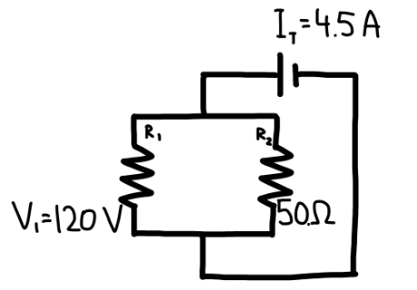
- A DC power source is connected to two resistors in parallel, as shown in the circuit diagram. The following information is known:
- The total current supplied by the source is $I_{\text{total}}=4.5\text{ A}$
- The voltage across $R_{1}$is $V_{1}=120\text{ V}$
- The resistance of the second resistor is $R_{2}=50 Ω$
Assume all components are ideal and the resistance of the connecting wires is negligible.

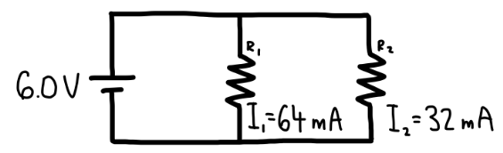
- A 6.0 V DC battery is connected to two resistors in parallel, as shown in the circuit diagram. The following information is known:
- The current through resistor $R_{1}$is $I_{1}=64\text{ mA}$
- The current through resistor $R_{2}$is $I_{2}=32\text{ mA}$
Assume all components are ideal and the resistance of the connecting wires is negligible.

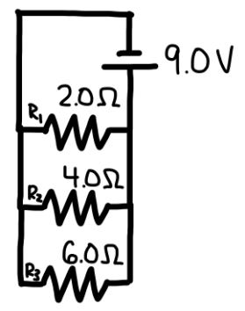
- A 9.0 V DC battery is connected to three resistors in parallel, as shown in the circuit diagram:
- $R_{1}=2.0 Ω$
- $R_{2}=4.0 Ω$
- $R_{3}=6.0 Ω$
Assume all components are ideal and that the resistance of the connecting wires is negligible.

