Motion Graphs

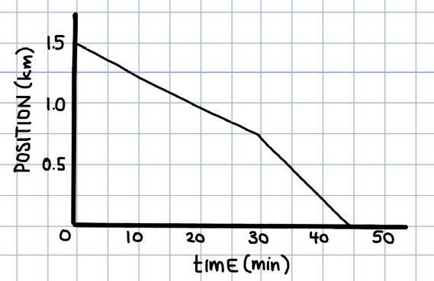
            - Use the following position vs. time graph to answer the following:

  - What is the speed of the object between 0 and 30 minutes?
  - What is the speed of the object 30 and 45 minutes?
  - What is the average speed of the object from 0 to 45 minutes?

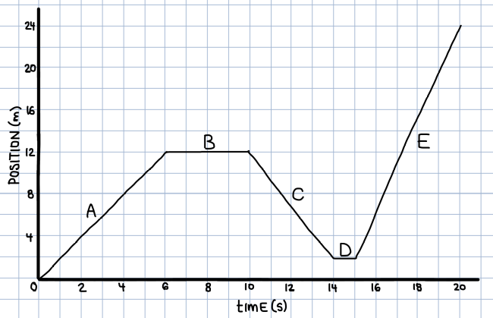
            - Use the following position vs. time graph to answer the following:

  - When is the object moving the fastest?
  - When is the object moving in the positive direction?
  - When is the object moving in the negative direction?
  - When is the object not moving?
  - What is the average velocity of the object between 0 and 20 seconds?
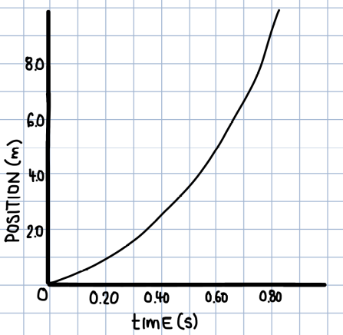
            - Use the following position vs. time graph to answer the following:

- What is the average speed of the object between 0 and 0.80 s?
- What is the instantaneous speed of the ball at 0.60 s?

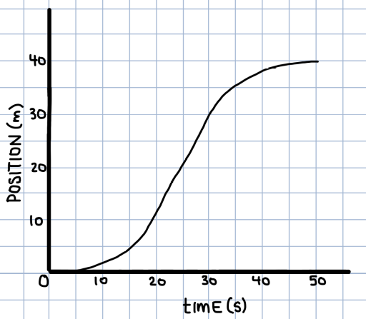
            - Use the following position vs. time graph to answer the following:

- What is the average speed of the object between 0 and 50 s?
- What is the instantaneous speed of the object at 25 s?
- When is the object speeding up?
- When is the object slowing down?

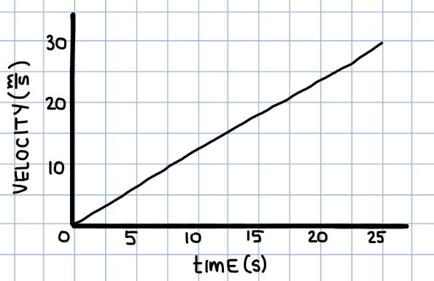
- Use the following velocity vs. time graph to answer the following:
- What is the displacement of the object over the 25 seconds?
- What is the acceleration of the object in this time?

- Use the following velocity vs. time graph to answer the following:
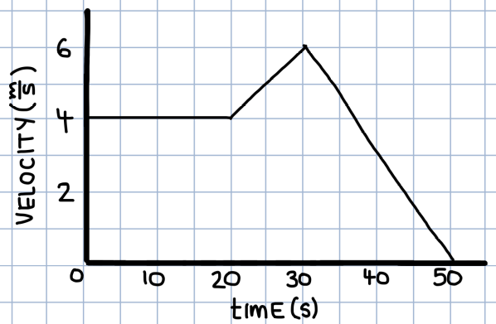
- What is the displacement of the object over the 50 seconds?
- Describe the motion of the object between 0 and 20 s.
- When is the object moving in the positive direction? negative direction?
- What is the acceleration of the object between 20 and 30 s?
- What is the acceleration of the object between 30 and 50 s?
- What is the average acceleration of the object over the 50 seconds?
- What is the average speed of the object over the 50 seconds?
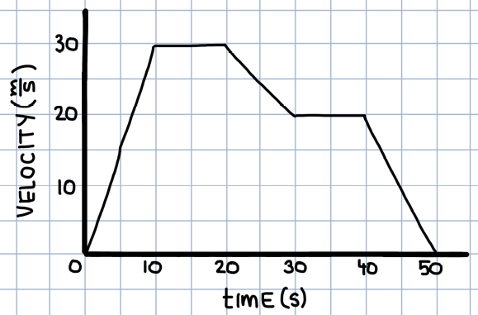
- Use the following velocity vs. time graph to answer the following:
- When is the velocity of the object the greatest?
- When is the acceleration of the object the greatest (most positive)?
- When is the acceleration of the object zero?
- When is the object slowing down?
- What is the displacement of the object over the 50 s?

- Use the following velocity vs. time graph to answer the following:
- When is the object moving in the positive direction?
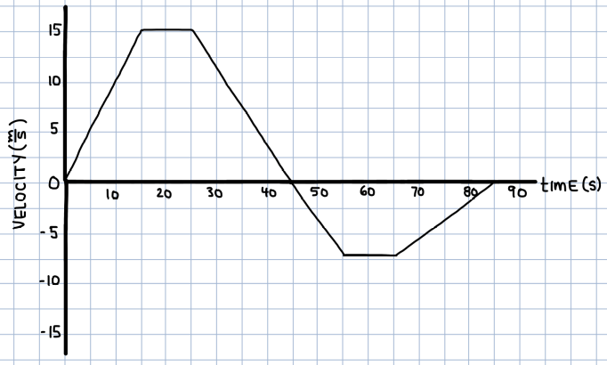
- When is the object moving in the negative direction?
- What is the displacement of the ball from 0 to 45 s?
- What is the displacement of the ball from 45 to 85 s?
- What is the total displacement of the ball between 0 and 85 s?
- What is the total distance travelled between 0 and 85 s?
- What is the average velocity over the 85 seconds?

