Polynomial Functions from Graphs

- Write a possible polynomial function in factored form.
- Determine the value of the leading coefficient.
- Write the function $P(x)$in expanded (standard) form.

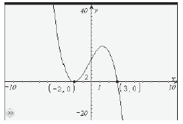
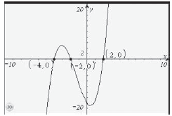

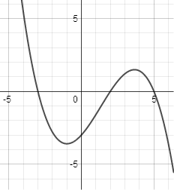
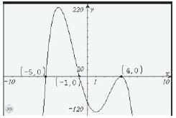

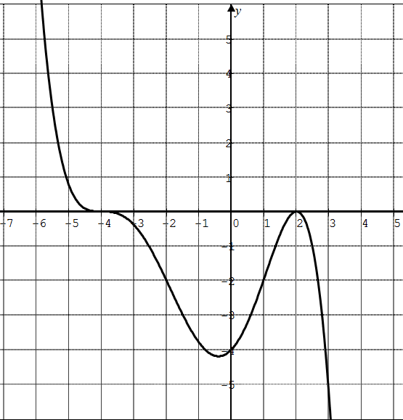
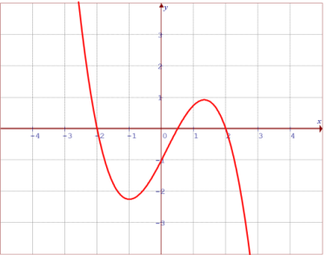
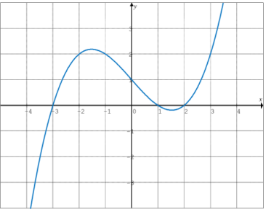
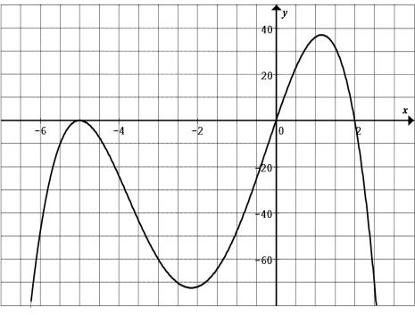
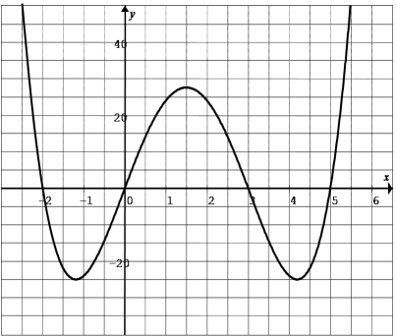

- Identify potential x-intercepts and determine the multiplicity of each intercept.
- Determine the value of the leading coefficient.
- Write a possible polynomial function in factored form.
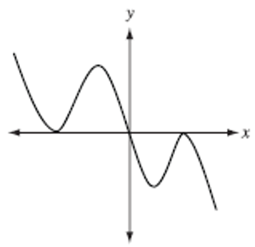
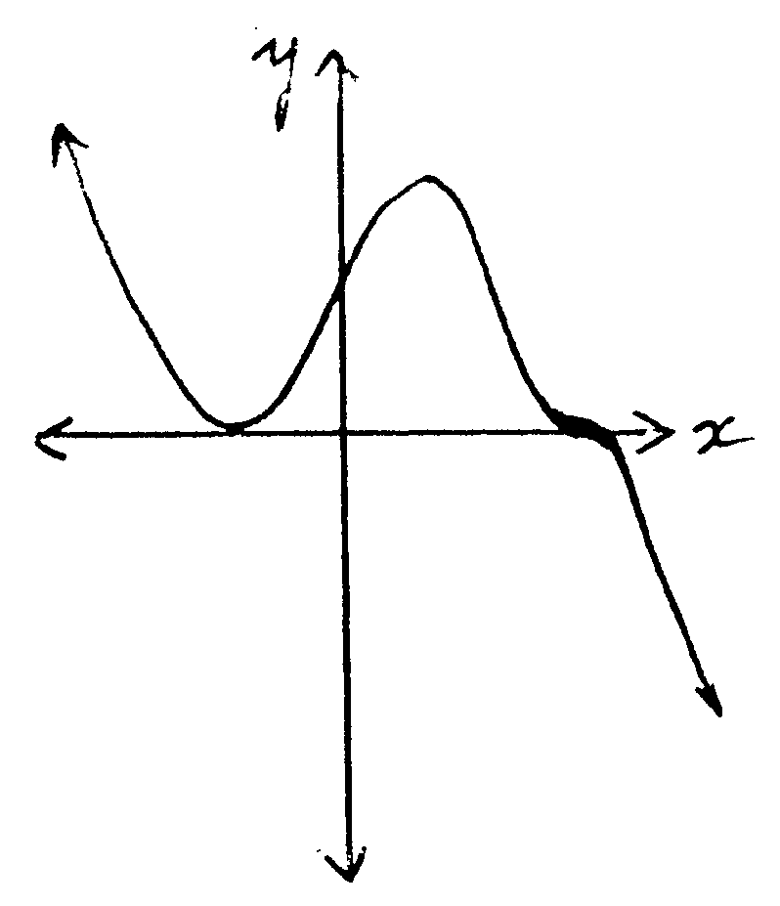
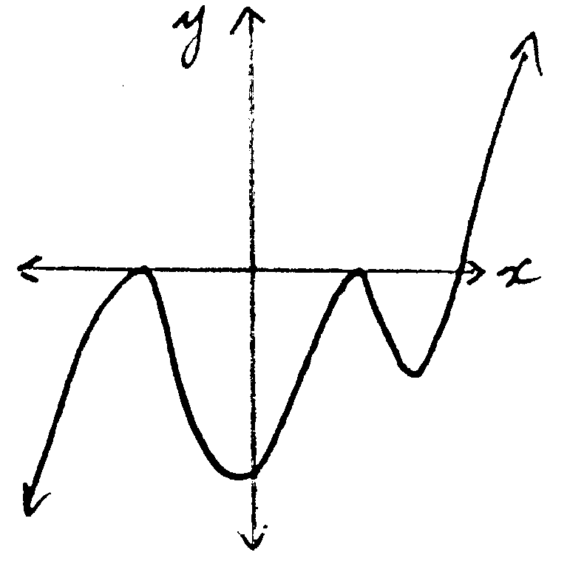

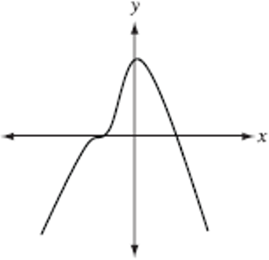

The graphs of four polynomial functions are shown below. Each polynomial function is of the minimum degree consistent with its graph. Match each of the polynomial graphs shown above with a description that applies to it:

- A graph of a fourth-degree polynomial function with a zero of multiplicity 2 would be _________.
- A graph with a negative y-intercept would be __________.
- A graph of a polynomial function with a negative coefficient of the term of the largest degree and all zeros of multiplicity 1 would be __________.
- A graph of a fifth-degree polynomial function would be __________.

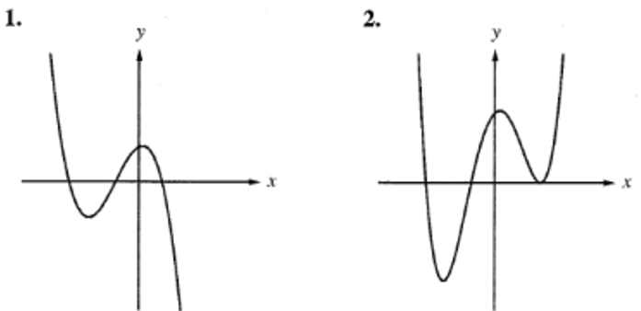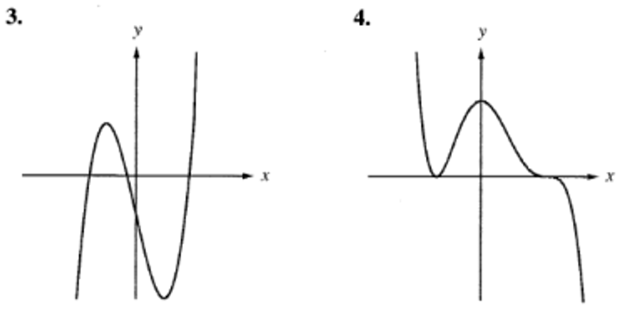

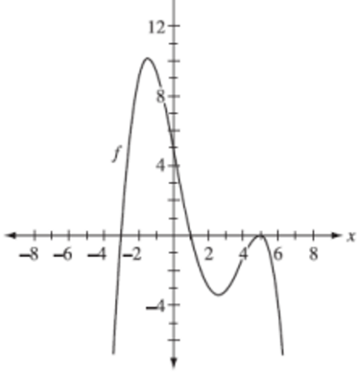
Determine an equation of the function in factored form.

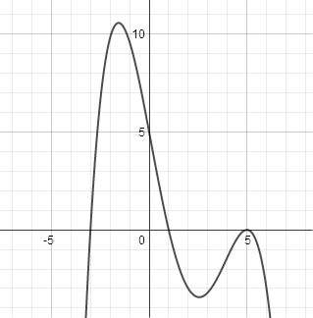
A polynomial function is shown.
From the graph:
- The function crosses the x-axis at approximately x = −3
- The function touches and turns at x = 5
- The y-intercept appears to be (0, 5)
If the function is written in factored form as $f(x)=a(x+3)(x-5)^{2}$ find the value of $a$.

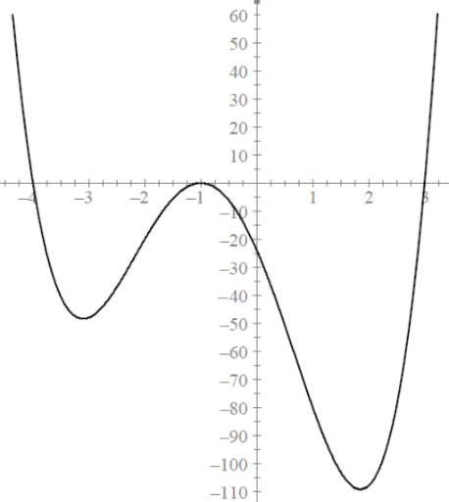
A partial graph of a fourth-degree polynomial function $f$is shown.
- The x-intercepts are −4, −1, and 3
- The y-intercept is −24
Assume the graph matches this information and behaves as a typical quartic polynomial.
- Write the polynomial function in factored form.
- Determine the value of the leading coefficient.
- If $f\left(x\right)=a{\left(x+b\right)}^{2}\left(x+c\right)\left(x-d\right)$, what are the values of $a,b,c,and d$where they are all positive.

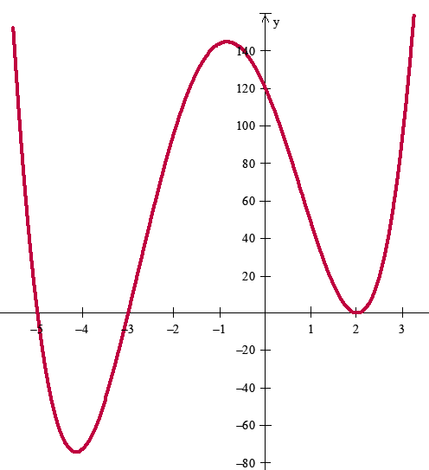
The partial graph of a fourth degree function, $f(x)$, is shown above. The x intercepts are -5, -3, and 2 and the y intercept is 120. If $f\left(x\right)=a{\left(x-b\right)}^{2}\left(x+c\right)\left(x+d\right)$, where $a,b,c,andd$are all positive, then what are a, b, c, and d?

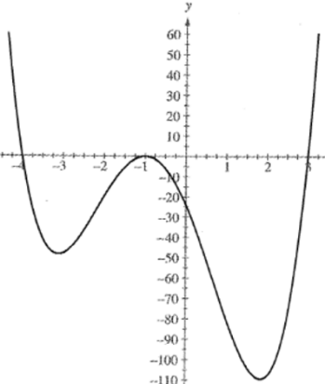
The partial graph of a fourth-degree polynomial function, f, is shown below. The x-intercepts are –4, –1, and 3, and the y-intercept is –24. If $f(x)=a{(x+b)}^{2}(x+c)(x-d)$, where a, b, c, and d are all positive, then the numerical value of a, b, c, and d are?

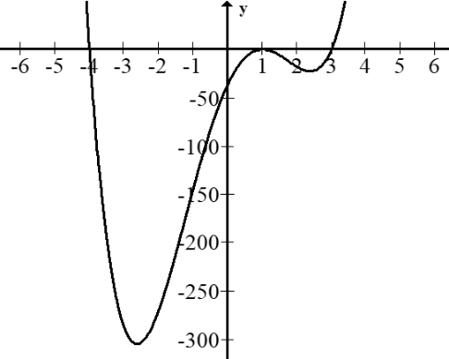
The partial graph of the polynomial $P(x)$ shown below has a y-intercept of $(0,-36)$ and can be expressed as a polynomial function of the form $P(x)=a(x-b)(x-c)(x-d)^{2}$. The value of a is . The value of d is .

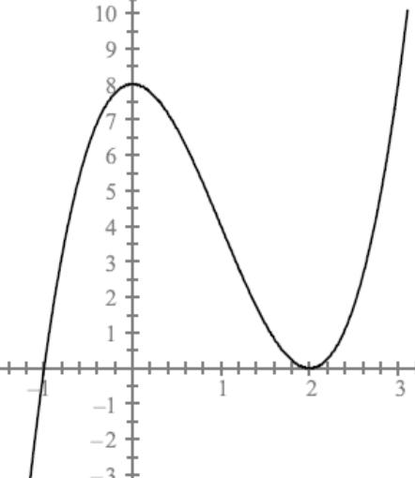
A student graphed a third-degree polynomial function and obtained the partial graph shown.
- The x-intercepts are −1 and 2
- The y-intercept is 8
The graph shows that the curve touches the x-axis at $x=2$.
If the point $\left(3 , k\right)$is on the graph of the function, then the value of $k$is __________.

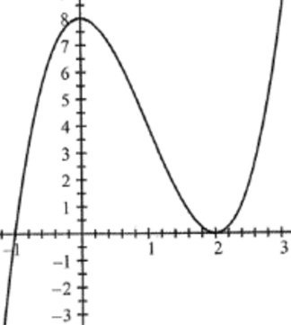
A student graphed a third-degree polynomial function and obtained the partial graph. The x-intercepts are –1 and 2, and the y-intercept is 8. If the point (15 , b) is on the graph of the function, then the value of b is __________.

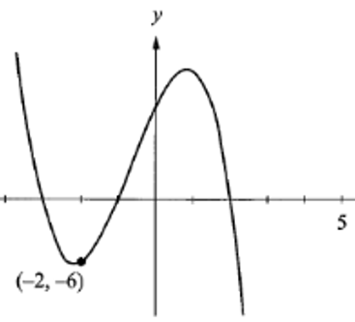
The graph of a third-degree polynomial function P with x-intercepts of –3, –1, and 2 is shown below. The point (–2 , –6) lies on the graph of y = P(x). The value of the y-intercept is?

