Kinematics Review

- A hiker walks 300 m 15° east of south. Find the x and y components.

- A student walks 200 m south, then 150 m east. Find the resultant displacement.

- Bob walks 500 m 25º east of south, then 600 m north. What is his total displacement?

- A cabin is (4 km, 0) east of a trailhead; a lake is (0, 3 km) north of the trailhead. What is the displacement from cabin to lake?

- A runner starts at 2 km west, 1 km south of the stadium and finishes 1 km east, 2 km north of the stadium. Find the displacement from start to finish.

- A car is initially 6 km east of home. Thirty minutes later, it is 3 km south of home.
  - What is the displacement of the car during the 30 minutes?
  - If the path driven to get there was 10.5 km in 30 min, what was the average speed?

- A plane travels with an airspeed of 600 km/h and aims 40º west of north. An 80 km/h wind blows south. Draw a vector diagram of the plane relative to the ground?

- A plane flies due north at 600 km/h with a headwind of 80 km/h from the west, what is the ground speed of the plane?

- Bob instead walks 500 m 25° east of south, then 600 m north, then 200 m west.
  - What is his final displacement from the start?
  - What single bearing should Bob have taken to end at the same point in one straight walk?
  - If Bob’s walk took 18 minutes, what are his average speed and average velocity?

- A ball rolls off the 50 m cliff at 12 m/s horizontally. Find time of flight, range, and impact angle.

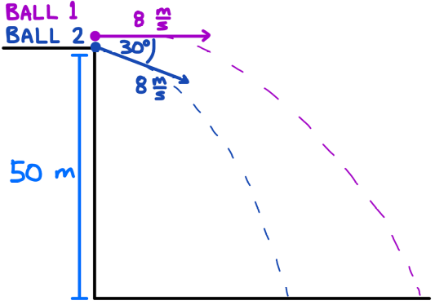
- Two balls are launched from a 50 m high cliff as shown.

  - Determine the range and impact velocity of each ball.
  - If both balls are launched at the same speed but at different angles (one above, one below horizontal), which has the greater range and why?
  - How would a headwind vs. tailwind qualitatively change range and impact angle?

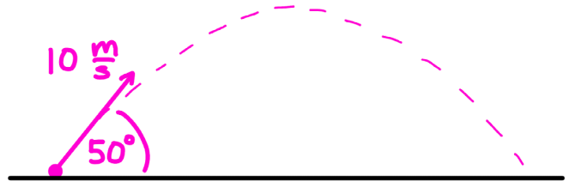

- A ball is launched from level ground at a velocity of 10 m/s 50º above the horizontal.
  - Determine the maximum height
  - Determine the range
  - Determine the impact velocity
  - Imagine you need the ball to travel a horizontal distance of 9.0 m with the same 10 m/s speed. Find two possible angles that achieve it.
  - If the launch speed limit is 8.0 m/s, what single angle maximizes the range, and what is that maximum range?

