More Projectiles Launched at Angles

- A projectile is launched from a 50 m high cliff with a velocity of 40 m/s 30º above the horizontal.

  - What are the initial speeds vertically and horizontally?
  - How long is the projectile in the air?
  - What is the horizontal distance travelled by the projectile?
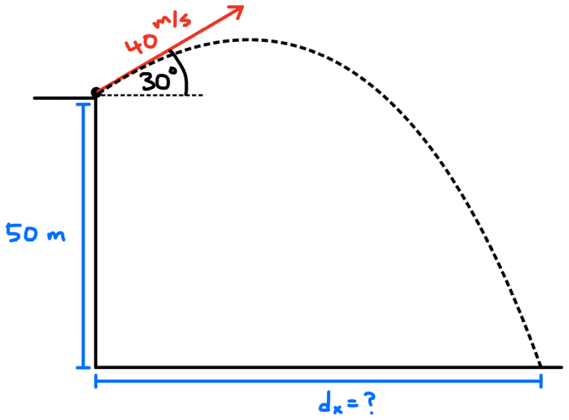
  - What is the impact velocity?

- Anna throws a ball from a 8.0 m high tower towards Bobby at a velocity of 10 m/s 20º below the horizontal.

  - What are the initial speeds vertically and horizontally?
  - How long is the ball in the air?
  - How far from the tower should Bobby stand to catch the ball?
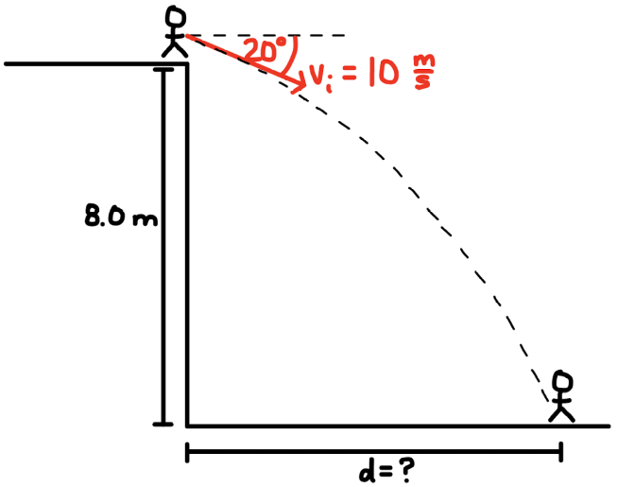
  - What is the velocity upon impact?

- A rock is thrown from the top of a 10 m high building at a velocity of 10 m/s 37º above the horizontal. A 6 m tall tree is 12 m from the building.

  - What are the initial speeds vertically and horizontally?
  - How long is the rock in the air?
  - What is the horizontal distance travelled by the rock?
  - What maximum height above the ground does the ball reach?
  - What is the velocity upon impact with the ground?
  - Will the rock make it over the tree?
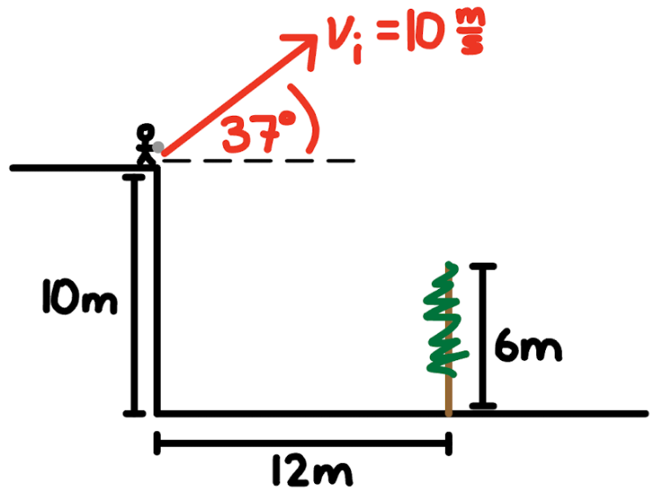

- A catapult flings a rock from a castle wall of height 60.0 m. The initial velocity of the rock is 80.0 m/s at an angle of 25° above the horizontal.

  - Sketch the setup of the catapult showing the location of the catapult, castle wall and rock.
  - What are the initial speeds vertically and horizontally?
  - How long is the rock in the air?
  - What is the horizontal distance travelled by the rock?
  - What maximum height above the ground does the ball reach?
  - What is the velocity upon impact?
  - If there is a 75 m high tree along the flight path 76 m from the wall, will the rock clear the tree? If so, by how much?

