Even More Horizontal Projectiles

- A swimmer runs at 5.0 m/s off the top of a cliff into a lake. He lands 8.0 m from the cliff.

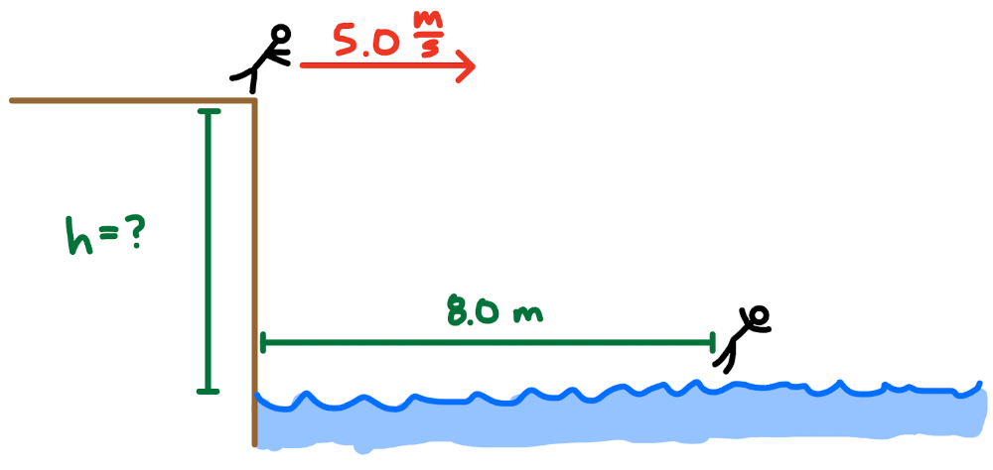

  - How long will the swimmer be in the air?
  - How high is the cliff?
  - What is the swimmers vertical velocity just before hitting the water?
  - What is the swimmers velocity just before hitting the water?

- A rock is thrown horizontally at 15 m/s from the top of a 9.0 m high building. There is a 4.0 m tall tree 10.0 m away from the building.

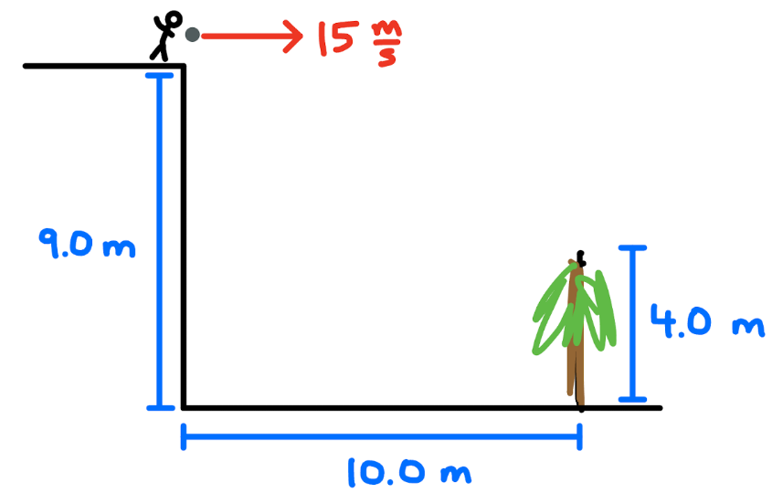

  - How long is the rock in the air?
  - How long has the rock been in the air after falling for 5.0 m?
  - How far (horizontally) does the rock travel after falling for 5.0 m?
  - Does the rock make it over the tree?
- You are on the second floor, 6.0 m above the ground. You see a Dragonite 12.0 m away, outside the building.

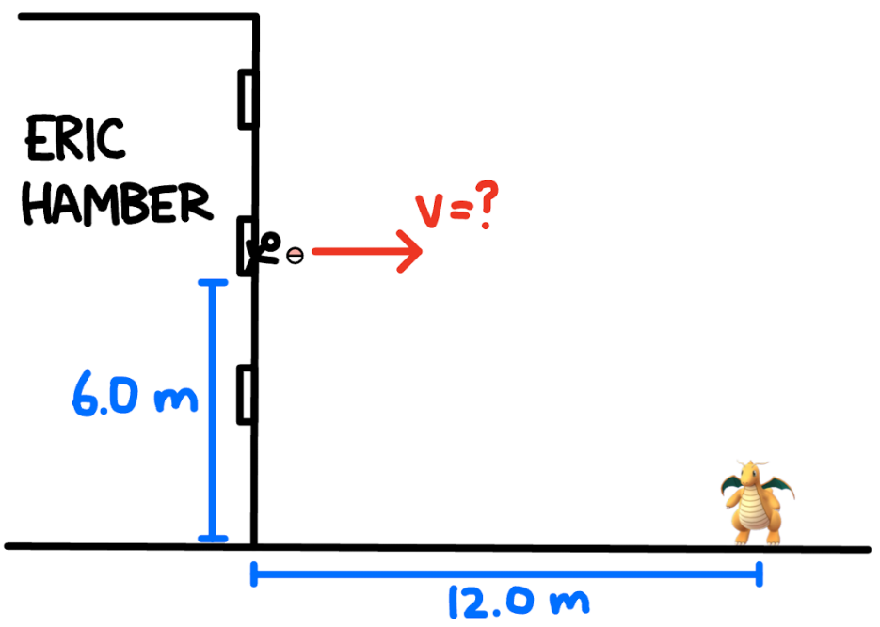

  - If you release the ball horizontally, what speed must you throw the Pokéball in order for it to hit the Dragonite?
b) If your friend is on the third floor, at what speed must they throw the ball? How will the speed at which he must throw the Pokéball compare to yours?

- A rock is thrown horizontally from the top of a 12 m high building over an 8.0 m high tree that is growing 11 m from the base of the building.

  - Sketch an image of the object being thrown over the tree and label the sketch appropriately.
  - What is the minimum speed the rock must be thrown to make it over the tree?
  - How long does it take the rock to reach the ground?
  - Calculate the velocity of the rock as it impacts the ground.

