The Tangent Ratio

CRITICAL DISCERNMENT: Scaling the value of the tangent ratio, $\tan{θ}=\frac{opposite}{adjacent}$, can be used to indirectly measure lengths.

A triangle represented by a tangent ratio of $\tan{θ}=\frac{opposite}{adjacent}$ is shown. Find the length of x.
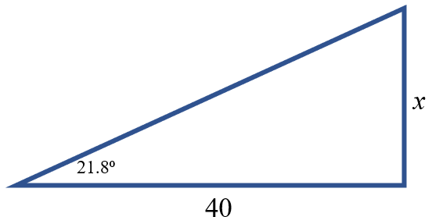

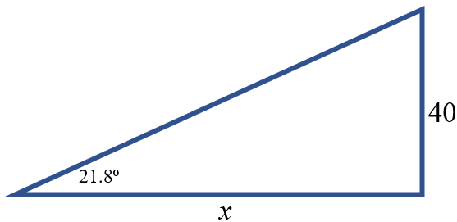

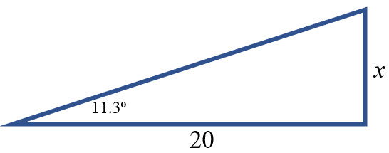
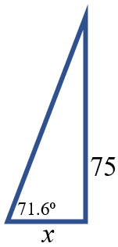

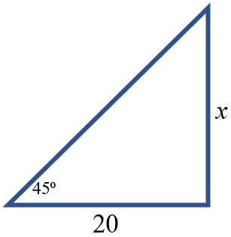

The Sine Ratio

CRITICAL DISCERNMENT: Scaling the value of the sine ratio, $\sin{θ}=\frac{opposite}{hypotenuse}$, can be used to indirectly measure lengths.

A triangle represented by a sine ratio of $\sin{θ}=\frac{opposite}{hypotenuse}$ is shown below. Find the length of x.
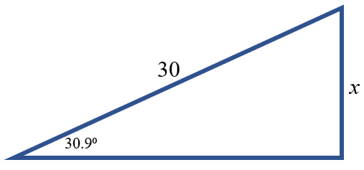

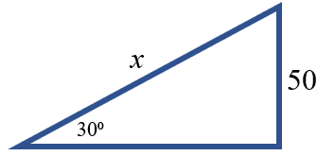

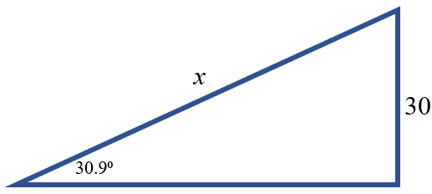
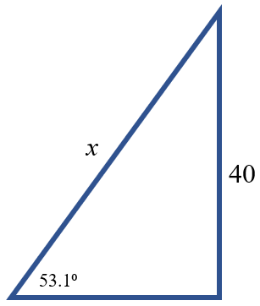
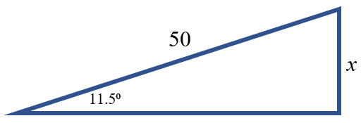
The Cosine Ratio

CRITICAL DISCERNMENT: Scaling the value of the cosine ratio, $\cos{θ}=\frac{adjacent}{hypotenuse}$, can be used to indirectly measure lengths.

A triangle represented by a sine ratio of $\cos{θ}=\frac{adjacent}{hypotenuse}$ is shown below. Find the length of x.
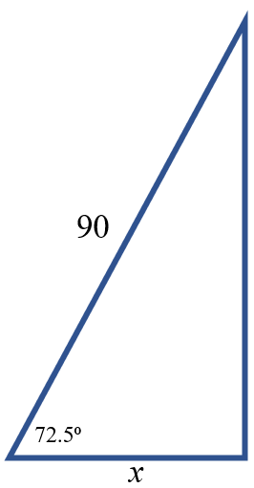
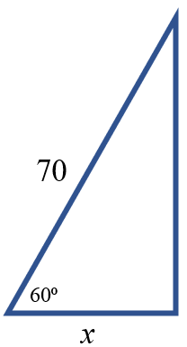
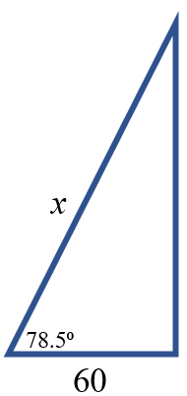
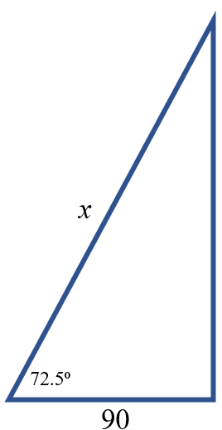
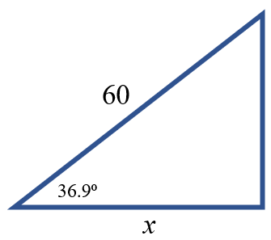
Trigonometric Ratios

$\sin^{-1}\left(\frac{opposite}{hypotenuse}\right)=θ$ $\cos^{-1}\left(\frac{adjacent}{hypotenuse}\right){=θ }$ $\tan^{-1}\left(\frac{opposite}{adjacent}\right)=θ$

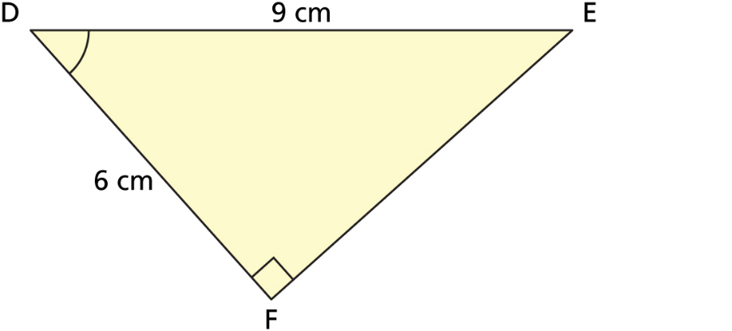
Determine the measure of the marked angle.

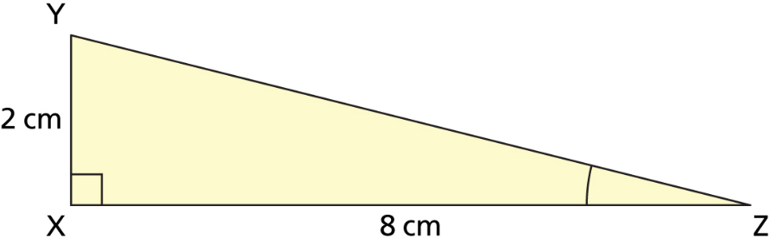

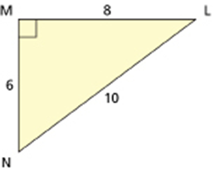

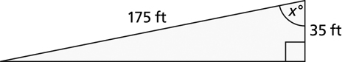

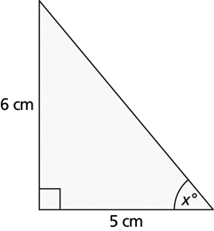
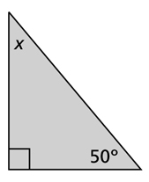

Trigonometric Ratios

$\sin{θ= \frac{opposite}{hypotenuse}}$ $\cos{θ= \frac{adjacent}{hypotenuse}}$ $\tan{θ= \frac{opposite}{adjacent}}$

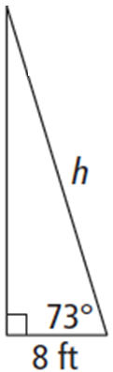
Natalie is rock climbing and Aaron is belaying. When Aaron pulls the rope taut to the ground, the angle of depression is 73°. If Aaron is standing 8 ft from the wall, what length of rope is off the ground?

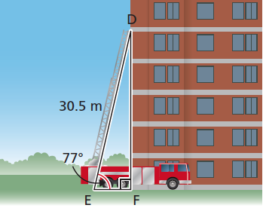
A fire truck has an aerial ladder that extends 30.5 m measured from the ground. The angle of inclination of the ladder is 77°. How far up the wall of an apartment building can the ladder reach?

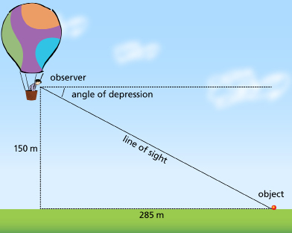
What is the angle of depression of the person’s line of sight 150 m up and 285 m to the object on the ground?

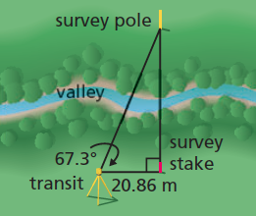
A surveyor made the measurements shown in the diagram. How could the surveyor determine the distance from the transit to the survey pole?

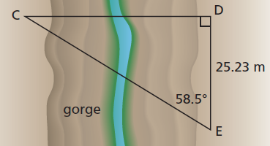
A surveyor makes the measurements shown in the diagram to determine the distance from C to E across a gorge. What is the distance from C to E?

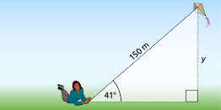
A kite has a string 150-m long. If the string makes an angle of 41° with the ground, find the height of the kite above the ground.

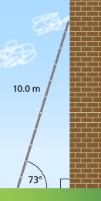
A 10.0-m ladder leans against a vertical wall. The angle between the ladder and the ground is 73°. Find the distance from the foot of the ladder to the wall.

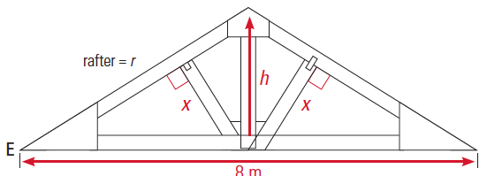
The angle of elevation of a rafter is 32°. The width of the structure is 8 m. Find the missing lengths.

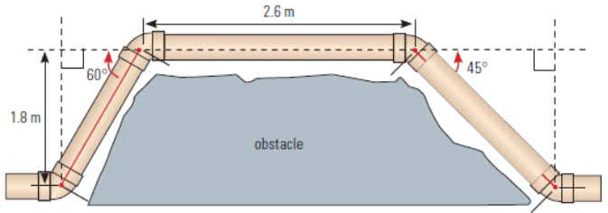
How far is it from the end of one lower pipe to the other?

How much pipe will be needed in total to get around the obstruction?

Trigonometric Ratios

$\sin{θ= \frac{opposite}{hypotenuse}}$ $\cos{θ= \frac{adjacent}{hypotenuse}}$ $\tan{θ= \frac{opposite}{adjacent}}$

From the top of a 350 m tall building the angle of elevation to the top of another building is 52°. The angle of depression to the bottom of the second building is 60°. How tall is the second building?
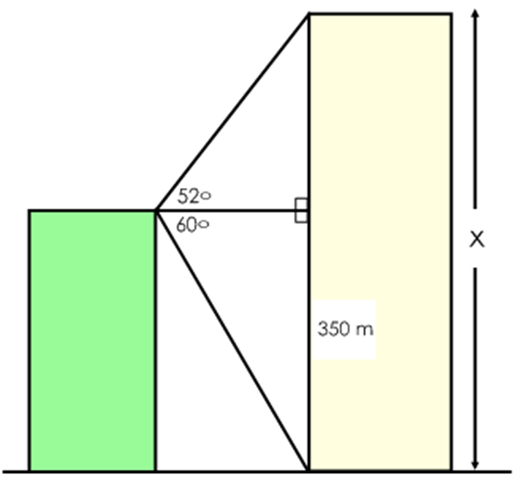

You are given the following diagram showing a flagpole outside a second-storey window. Use the information in the diagram to find the height of the flagpole. Distance d = 20 m.

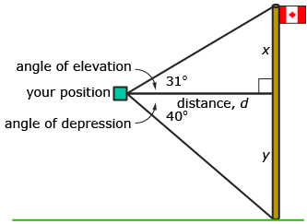

A person is standing 275 feet from the base of a building. The angle of elevation to the base of the tower’s antennae is 32º. The angle of elevation to the top of the antenna is 42º. How tall is the antenna?

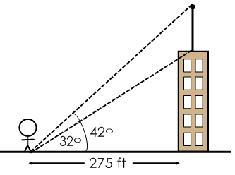

Two people are at points A and B on a straight road. They are approaching a 20 m tall fire tower (T ). The angles of elevation to the top of the tower from the two people are 40º and 60º. How far apart are the people?

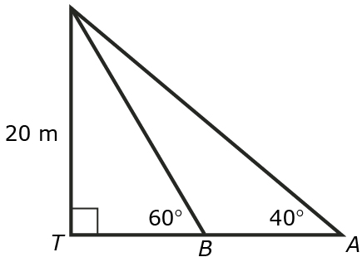

A roller coaster at an amusement park heads upwards at an angle of 40 degrees for 50 meters along the slope, then drops right back to ground level over a horizontal distance of 30 meters. What is the angle of descent, indicated by x?

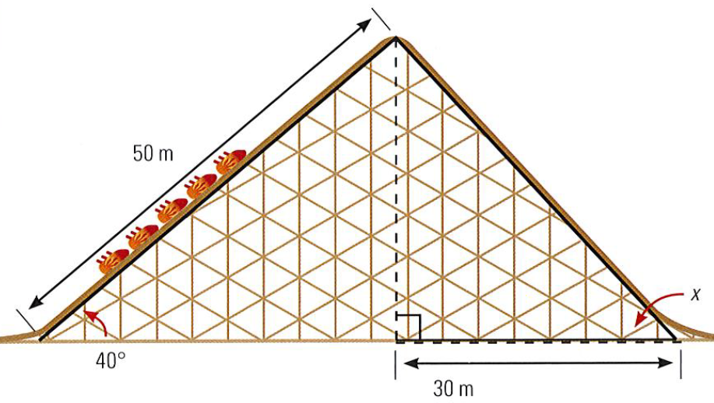

Eugene is building a triangular asymmetric roof truss as shown in the diagram. He wants to know to what length he must cut the base. What is the length of the base of the truss?

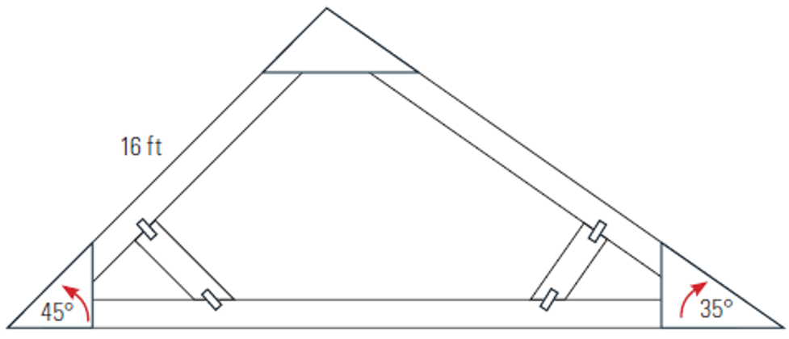

Calculate the unknown angles in the following diagram:
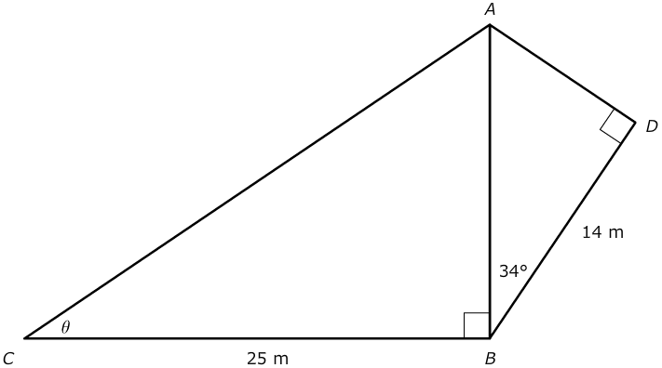

Solve for the unknowns in the following adjacent right-triangle problem.

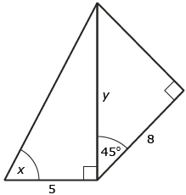

Sine Law

$\frac{\sin{A}}{a}=\frac{\sin{B}}{b}$ $\frac{a}{\sin{A}}=\frac{b}{\sin{B}}$

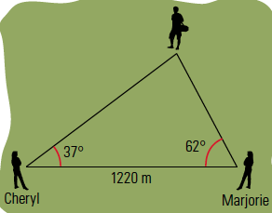
Marjorie observes the hiker at an angle of 62°, Cheryl observes him at an angle of 37°. If Marjorie and Cheryl are 1220 meters apart on opposite sides of the hiker, how far is Cheryl from the hiker?

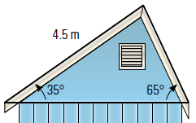
The roof of the shack will be asymmetrical, as shown in the diagram. The longer section of the roof is 4.5 m and forms an angle of 35° above horizontal. The shorter section of the roof forms an angle of 65° above horizontal. How long is the shorter section of the roof and how wide is the shed?

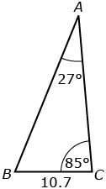
Use the Sine Law to find the length of c

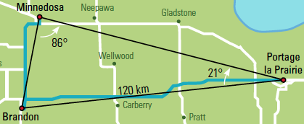
Huong is a truck driver. He is driving from Portage la Prairie, MB, to Brandon, MB, to drop off a shipment. From there, he will drive to Minnedosa and back to Portage la Prairie. How far will Huong drive?

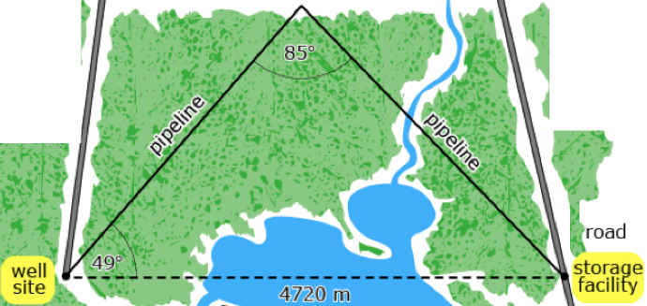
What is the length of the pipeline?

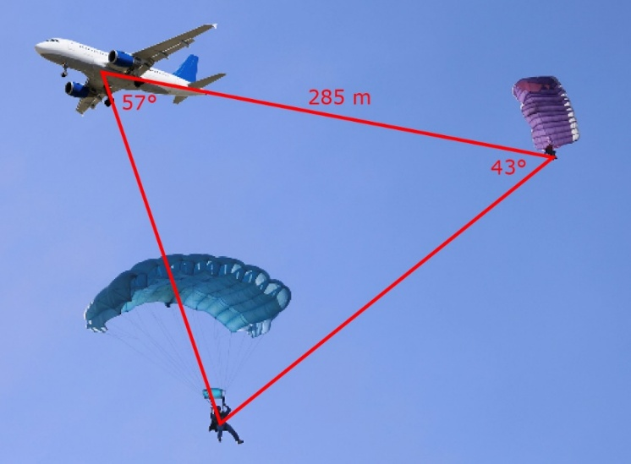
Tom and Tracy are skydiving. They both release their parachutes at the same time. Calculate the distance between Tom and Tracy, to the nearest tenth, given the information in the diagram.

Cosine Law

$$c^{2}=a^{2}+b^{2}-2ab cos C$$

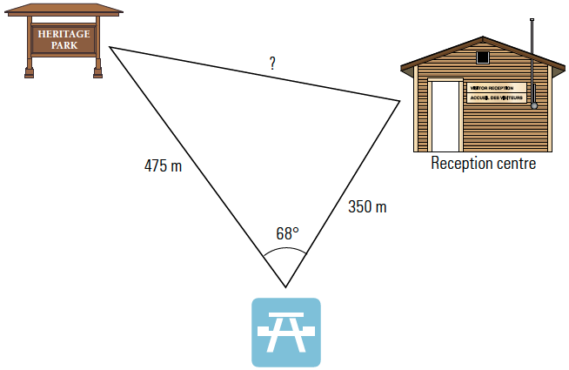
John has measured the straight-line distance between the reception centre and the picnic site as 350 metres, and the straight-line distance from the billboard to the picnic site as 475 metres. If the angle between the two lines is 68°, how far apart are the billboard and the reception centre?

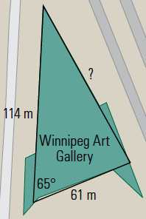
The Winnipeg Art Gallery houses one of the world’s largest collections of contemporary Inuit art. The building is in the shape of a triangle. Two of the outer walls form an angle of about 65° are approximately 61 m and 114 m in length. What is the length of the third side?

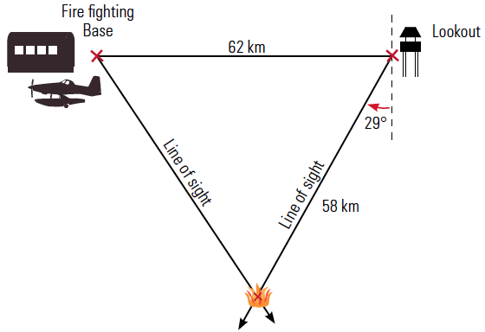
From a forest fire lookout station, a fire is spotted 29Åã degrees west of south. The fire is 58 km from the lookout station. A fire fighting base is 62 km due west of the first station. How far is the fire from the fire fighting base?

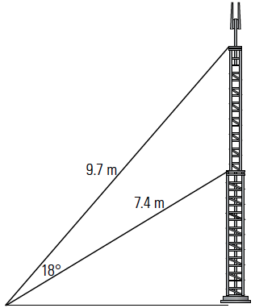
Guy wires are used to stabilize a mast. The difference between the angles of elevation of two guy wires is 18°. If the guy wires are 9.7 m and 7.4 m long, what is the distance between the two places on the mast where the guy wires are attached?

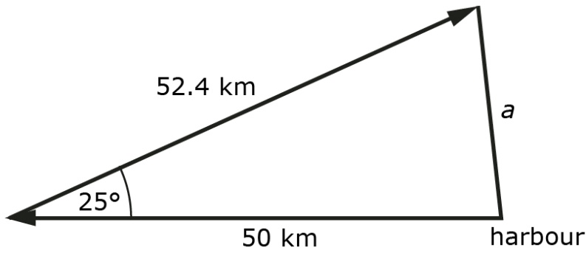
A ship leaves a harbour and travels west 50 km. It then sails 52.4 km in a direction of E25N, at which point the ship has engine trouble. A second ship is dispatched from the harbour to assist. If the second ship sails directly from the harbour to the first ship, how far must the second ship sail?

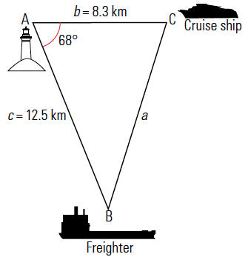
A lighthouse keeper at Trial Island Light Station observes a cruise ship at a distance of 8.3 km. At the same time, a freighter is observed at a distance of 12.5 km. If the angle between the lines of observation is 68°, how far apart are the freighter and the cruise ship?

