Volume & Polynomials

- The volume of a rectangular prism is: $V(x)=-x^{3}-3x^{2}+36x-32$. Factor the polynomial completely and determine expressions for the three dimensions.

- The volume of a rectangular prism is: $V(x)=x^{3}+3x^{2}-36x+32$. If the length is $x-4$, determine expressions for the width and height.

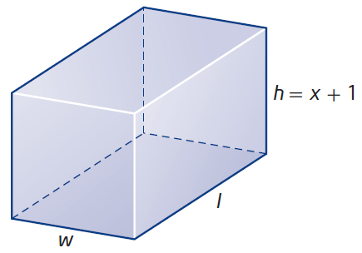
- The volume of nested boxes is: $V(x)=x^{3}+7x^{2}+14x+8$. If the height is $x+1$, determine expressions for the width and length.

- The volume of water in a fish tank is: $V(x)=x^{3}+14x^{2}+63x+90$. If the depth is $x+6$, determine the possible length and width expressions.

- A box is constructed so that:
- The length is twice the width.
- The height is 2 cm more than the width.
- The volume is 350 cm³.
Find the dimensions of the box.

- Fred and Ted are twins. They were born 3 years after their older sister Bethany. The product of their three ages is 5780. How old are the twins?

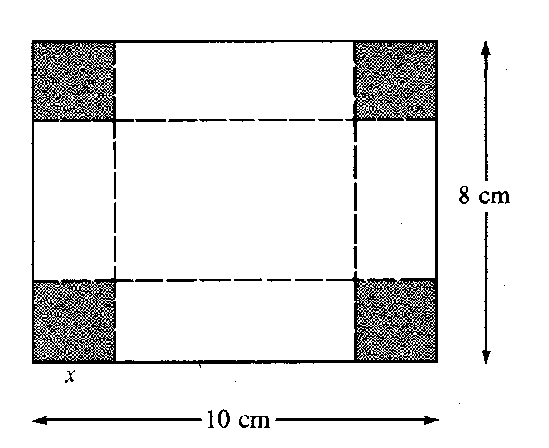
- A 10 cm by 8 cm piece of cardboard has squares cut from each corner and folded into an open-top box.
a) Write expressions for the dimensions.
b) Write the volume function.
c) Determine the value of $x$that produces a volume of 48 cm³.

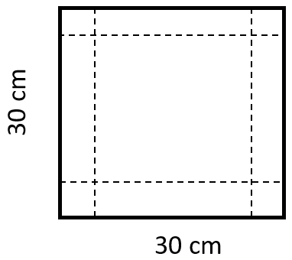
- A 30 cm square sheet is used to form an open-top box.
a) Write expressions for the dimensions.
b) Write the volume function.
c) Determine the value(s) of $x$that produce a volume of 2000 cm³.
d) State the domain of possible values for $x$.

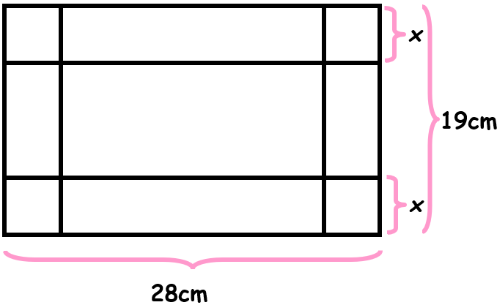
- A 28 cm by 19 cm sheet is used to form an open-top box.
a) Write expressions for the dimensions.
b) Write the volume function.
c) Determine the maximum possible volume.
d) What size square should be cut if the box must hold 750 cm³?

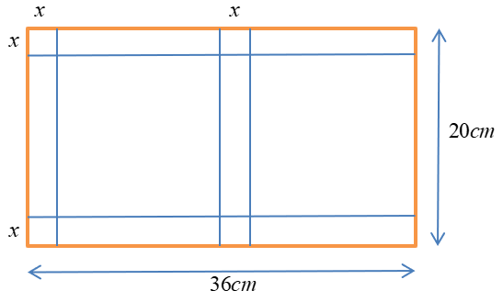
- Boxes for candies are constructed from 36 cm by 20 cm sheets.
(The base is half the sheet length.)
If the volume must be 512 cm³, determine the value of $x$.

