MATHEMATICS 12

Pre-calculus

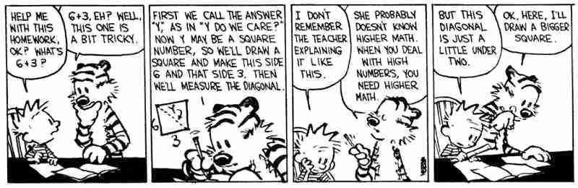

TABLE OF CONTENTS
TABLE OF CONTENTS 1
CLASSROOM EXPECTATIONS 2
INTRODUCTION 3
PROGRAM OF STUDIES 3
CONTENT 3
COURSE CALENDAR 3
ASSESSMENT 6

CLASSROOM EXPECTATIONS

Students are expected to:

- Refrain from the use of drugs or alcohol, including vaping.
- Refrain from verbal aggression and assault.
- Refrain from physical aggression and assault.

Students are expected to observe these classroom courtesies:

1. Be on time.
2. Come prepared to learn.
3. Demonstrate your learning each day.
4. Be respectful of the teacher, educational assistants, and classmates.
5. Respect the classroom environment.

Students are expected to be familiar with these classroom routines:

Cell Phones: Cell phones belong out of sight. Students will be provided with access to calculator apps such as Desmos Graphing Calculator and ClevCalc..

Hand-In: Students may hand in complete (or incomplete) activities at any time during the semester.

Hall Passes: Students are expected to fill out hall passes themselves and explain to staff where they are going, and for how long, before they leave the classroom.
Support: Students may access support rooms during class. Students are expected to fill out hall passes so that they might access the rooms that are supervised as well as the LART rooms that are available if students need extra one-on-one support.
Missed: If you are away from the classroom for a period of time, please contact me to establish expectations for at-home learning.
SHUT DOWNS

The curricular expectations of the class will be reduced in the event of a shutdown. Activities supporting learner acquisition of these will be posted on google classroom (zh4sjia). It is recommended that students learning these curricular outcomes at home do so by participating in activities that help develop each of the supporting learning outcomes listed in the program of studies.

INTRODUCTION

The Curriculum Introduces Mathematics, ensures Flexible Teaching and Learning, and establishes the Goals and Rationale of this and any other Mathematics Programs claiming to meet the standards of the BC Ministry of Education.

There are several Important Considerations outlined within the curriculum. These considerations are intended to be infused within the design of this program and during each of the daily activities. These considerations include Inquiry in Mathematics, Mathematical Habits of Mind, and First Peoples Knowledge and Perspectives.

PROGRAM OF STUDIES

The Curriculum is full of insightful suggestions for the development and implementation of learning activities in the classroom. Pay particular attention to the sections about the three Core Competencies: Communication, Thinking, and Personal and Social.

The tasks are intended to offer all students opportunities to engage in meaningful and rigorous mathematics that allow for the development of and each of the interrelated sub-competencies: Communicating, Collaborating, Creative Thinking, Critical and Reflective Thinking, Personal Awareness and Responsibility, Positive Personal and Cultural Identity, and Social Awareness and Responsibility.

The curriculum is designed around four Big Ideas: Using inverses is the foundation of solving equations and can be extended to relationships between functions, Understanding the characteristics of families of functions allows us to model and understand relationships and to build connections between classes of functions, and Transformations of shapes extend to functions and relations in all of their representations.

This program will be delivered via hand-crafted lessons and additionally supported through unique, curricular extension opportunities. Each activity will be vetted for its contribution to the development of the Curricular Competencies: Reasoning and Analyzing, Understanding and Solving, Communicating and Representing, and Connecting and Reflecting.

CONTENT

Your teacher will be approximately following this weighted grading schema:
Polynomial Functions & Transformations | 30%
Exponential & Logarithmic Functions | 30%
Trigonometric Functions | 30%
Final Project | 10%

COURSE CALENDAR

MATHEMATICS 12 SEMESTER PLAN
WEEK | MONDAY | TUESDAY | WEDNESDAY | THURSDAY | FRIDAY
Feb 2 - Feb 6 | Polynomial Functions & Transformations | Polynomial Functions & Transformations | Polynomial Functions & Transformations | Polynomial Functions & Transformations | Polynomial Functions & Transformations
Feb 9 - Feb 13 | Polynomial Functions & Transformations | Polynomial Functions & Transformations | Polynomial Functions & Transformations | Polynomial Functions & Transformations | School Based PD-Day
Feb 16 - Feb 20 | Family Day | Polynomial Functions & Transformations | Polynomial Functions & Transformations | Polynomial Functions & Transformations | Polynomial Functions & Transformations
Feb 23 - Feb 27 | Polynomial Functions & Transformations | Polynomial Functions & Transformations | Polynomial Functions & Transformations | Polynomial Functions & Transformations | Polynomial Functions & Transformations
Mar 2 - Mar 6 | Polynomial Functions & Transformations | Polynomial Functions & Transformations | Polynomial Functions & Transformations | Polynomial Functions & Transformations | Polynomial Functions & Transformations
Mar 9 - Mar 13 | Polynomial Functions & Transformations | POLYNOMIALS & TRANSFORMATIONS EXAM | Exponential & Logarithmic Functions | Exponential & Logarithmic Functions | Exponential & Logarithmic Functions
Mar 16 - Mar 20 | SPRING BREAK
Mar 23 - Mar 27 | SPRING BREAK
Mar 30 - Apr 3 | Exponential & Logarithmic Functions | Exponential & Logarithmic Functions | Exponential & Logarithmic Functions | Exponential & Logarithmic Functions | Good Friday
Apr 6 - Apr 10 | Easter Monday | Exponential & Logarithmic Functions | Exponential & Logarithmic Functions | Exponential & Logarithmic Functions | Exponential & Logarithmic Functions

MATHEMATICS 12 SEMESTER PLAN
WEEK | MONDAY | TUESDAY | WEDNESDAY | THURSDAY | FRIDAY
Apr 13 - Apr 17 | Exponential & Logarithmic Functions | Exponential & Logarithmic Functions | Exponential & Logarithmic Functions | Exponential & Logarithmic Functions | Exponential & Logarithmic Functions
Apr 20 - Apr 24 | Exponential & Logarithmic Functions | Exponential & Logarithmic Functions | Exponential & Logarithmic Functions | Exponential & Logarithmic Functions | Exponential & Logarithmic Functions
Apr 27 - May 1 | Exponential & Logarithmic Functions | Exponential & Logarithmic Functions | Exponential & Logarithmic Functions | Exponential & Logarithmic Functions | Exponential & Logarithmic Functions
May 4 - May 8 | Exponential & Logarithmic Functions | EXPONENTIALS & LOGARITHMS EXAM | Trigonometric Functions | Trigonometric Functions | District Based PD-Day
May 11 - May 15 | Trigonometric Functions | Trigonometric Functions | Trigonometric Functions | Trigonometric Functions | Trigonometric Functions
May 18 - May 22 | Victoria Day | Trigonometric Functions | Trigonometric Functions | Trigonometric Functions | Trigonometric Functions
May 25 - May 29 | Trigonometric Functions | Trigonometric Functions | Trigonometric Functions | Trigonometric Functions | Trigonometric Functions
Jun 1 - Jun 5 | Trigonometric Functions | Trigonometric Functions | Trigonometric Functions | Trigonometric Functions | Trigonometric Functions
Jun 8 - Jun 12 | Trigonometric Functions | Trigonometric Functions | Trigonometric Functions | Trigonometric Functions | Trigonometric Functions
Jun 15 - Jun 19 | Trigonometric Functions | TRIGONOMETRY  EXAM | FINAL PROJECT | FINAL PROJECT | FINAL PROJECT
Jun 22 - Jun 26 | FINAL PROJECT | FINAL PROJECT | FINAL PROJECT | FINAL PROJECT | Administrative Day

ASSESSMENT
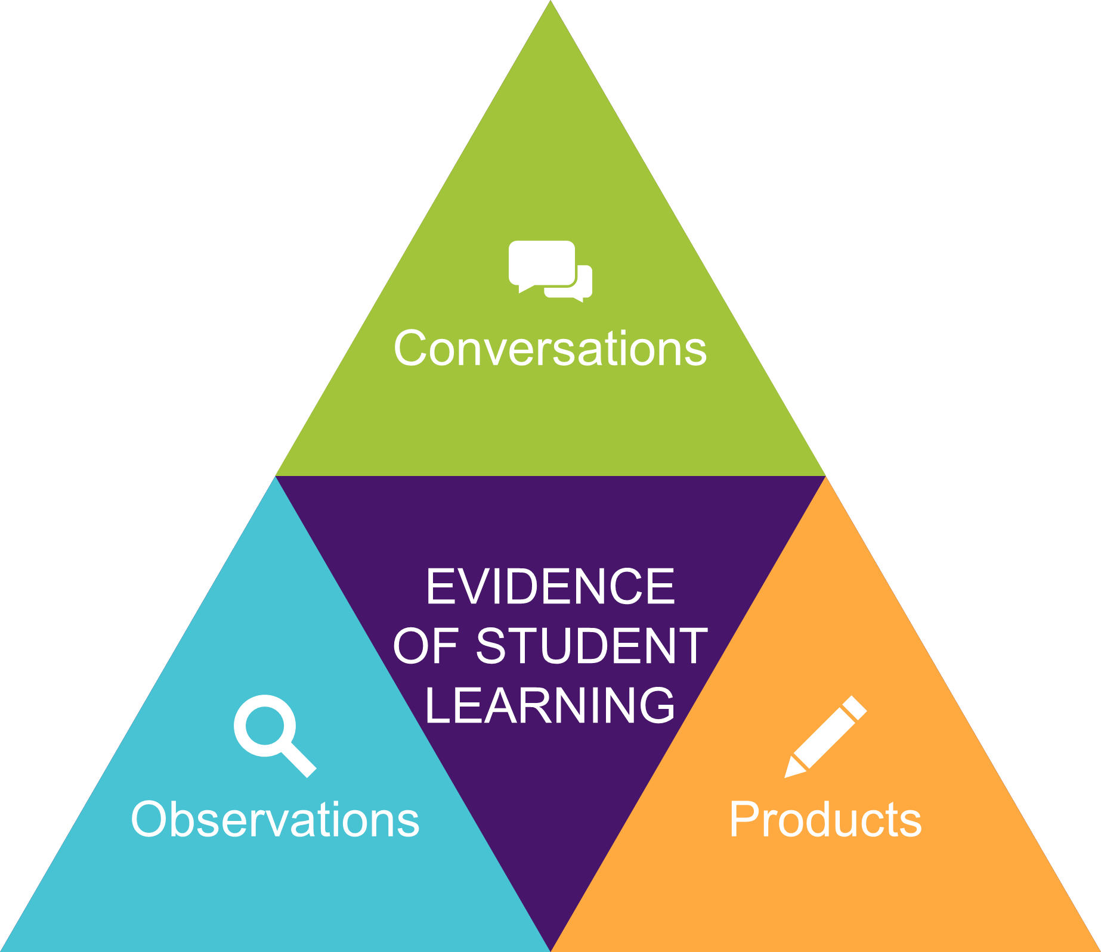
Your teacher is interested in observing the improvements and learning that take place rather than searching for errors on multiple choice exams.

As a result, you will be asked to demonstrate your learning through conversations, observations, and products. Everything counts,

This is a movement from a points-gathering system of grading to a data-gathering system. When learning is prioritised, assessment must reflect that.

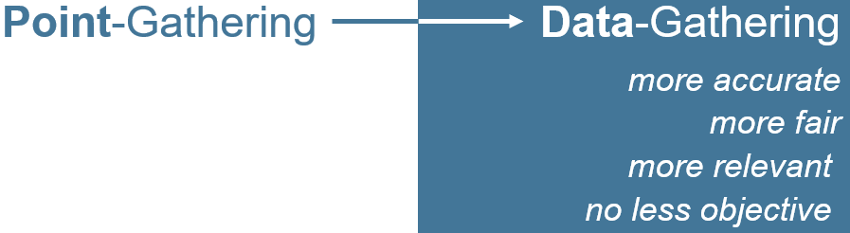

Students may not be able to meaningfully participate in activities without having previously discerned key mathematical attributes. Tasks might require students to have previously discerned one or more attributes in a given mathematical context. Previous learning and experiences will lend meaning and opportunity for students participating in inquiries as they apply what they have learned so far to new situations.

Students will need to engage in dialogue, discern key mathematical ideas, and overcome potential frustrations and impediments. Meaningful participation in tasks will alert educators to students who may wish to widen or deepen their understanding of the material and the purposes therein.

Summative Assessment will provide your teacher an opportunity to triangulate the data they have already gathered regarding your learning. Grades will be determined by looking at a student’s overall performance in each content area, taking into account the development of skills throughout the course and the consistency with which a student demonstrates those skills.

Unit exams will provide students with one last opportunity to demonstrate their learning before each report card. A final project will provide students with one last opportunity for learning in the last week of class.

